**PROJECT REPORT GAT**

BACHELOR OF TECHNOLOGY

in

COMPUTER SCIENCE AND ENGINEERING

with specialization in

**Open Source and Open Standards**

Submitted to Submitted by

**Dr. Durgansh Sharma** **Student Name – Pranay Gaur**

**Assitant Professor Roll No - R100217051**

**Department of Cybernetics SAP ID - 500062466**



**SCHOOL OF COMPUTER SCIENCE**

UNIVERSITY OF PETROLEUM & ENERGY STUDIES

Bidholi Campus, Energy Acres, Dehradun – 248007.

**TOPIC-** Implementation of AWP (CSGO)

**STEPS :-**

**Step 1**-Open the blender and start with a cube. Change it into cylinder to make the muzzle of the gun.

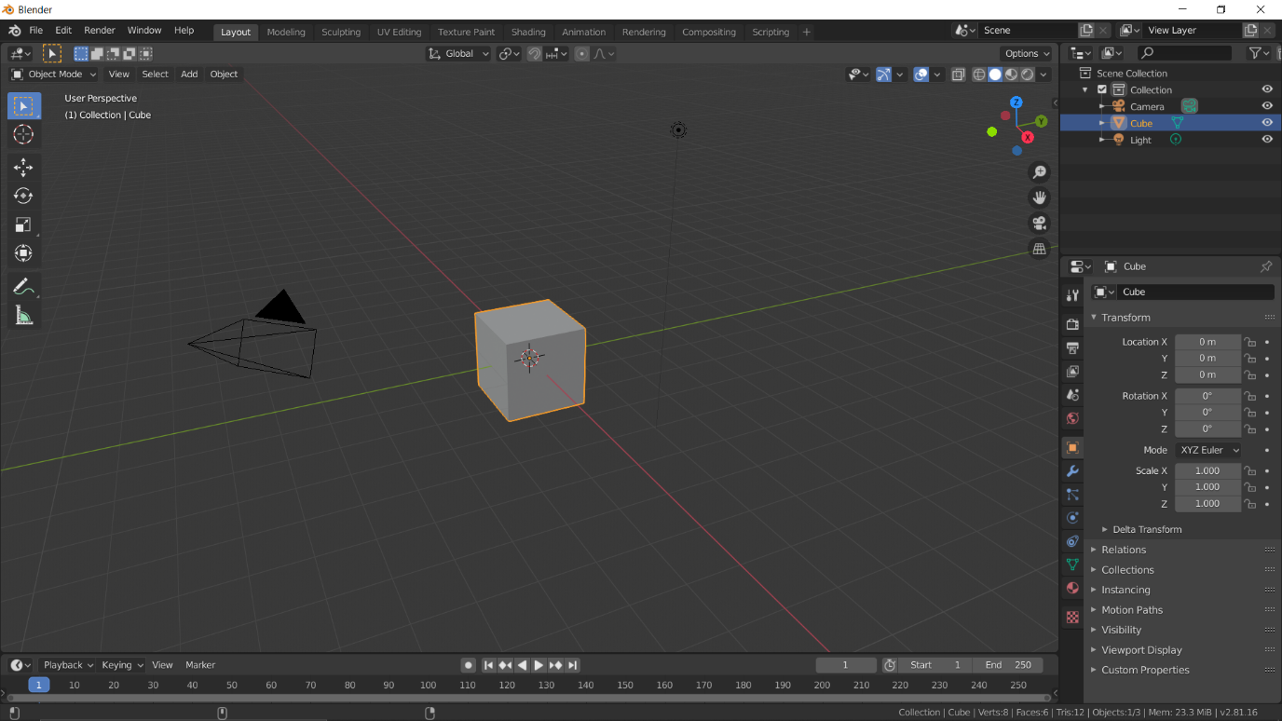

**Step 2**-Change into object mode by pressing the tab key and press E to extrude one side of the cylinder.

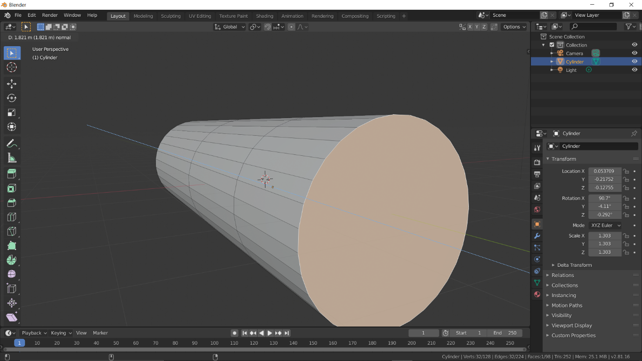

It will looks like this:-

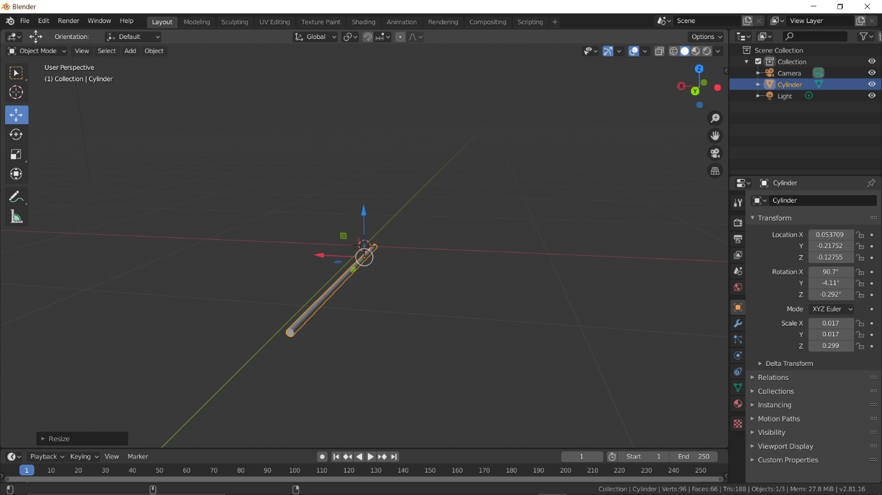

Press Shift+D to duplicate and move to the upper side and then again press Ctrl+J to join them.

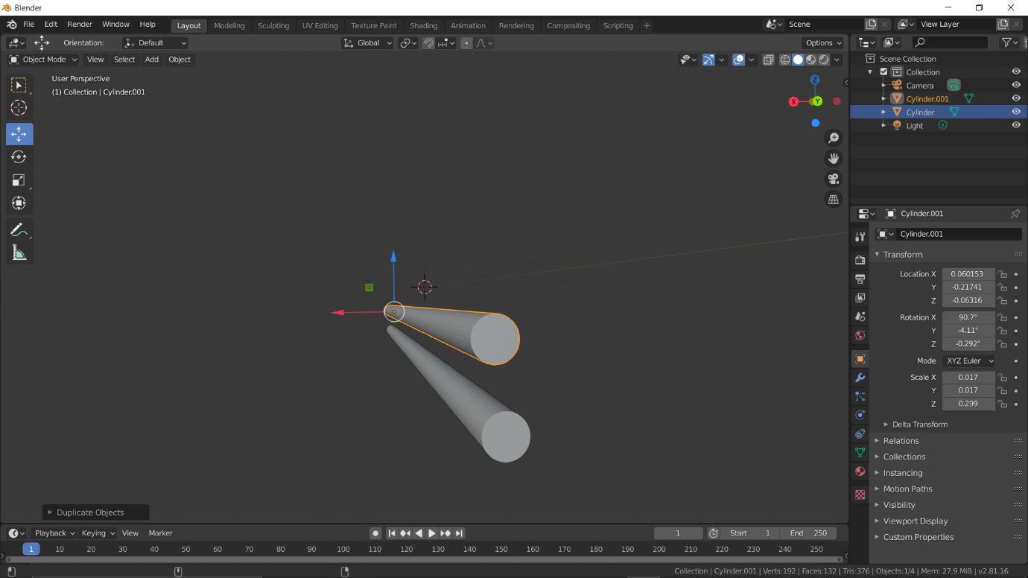

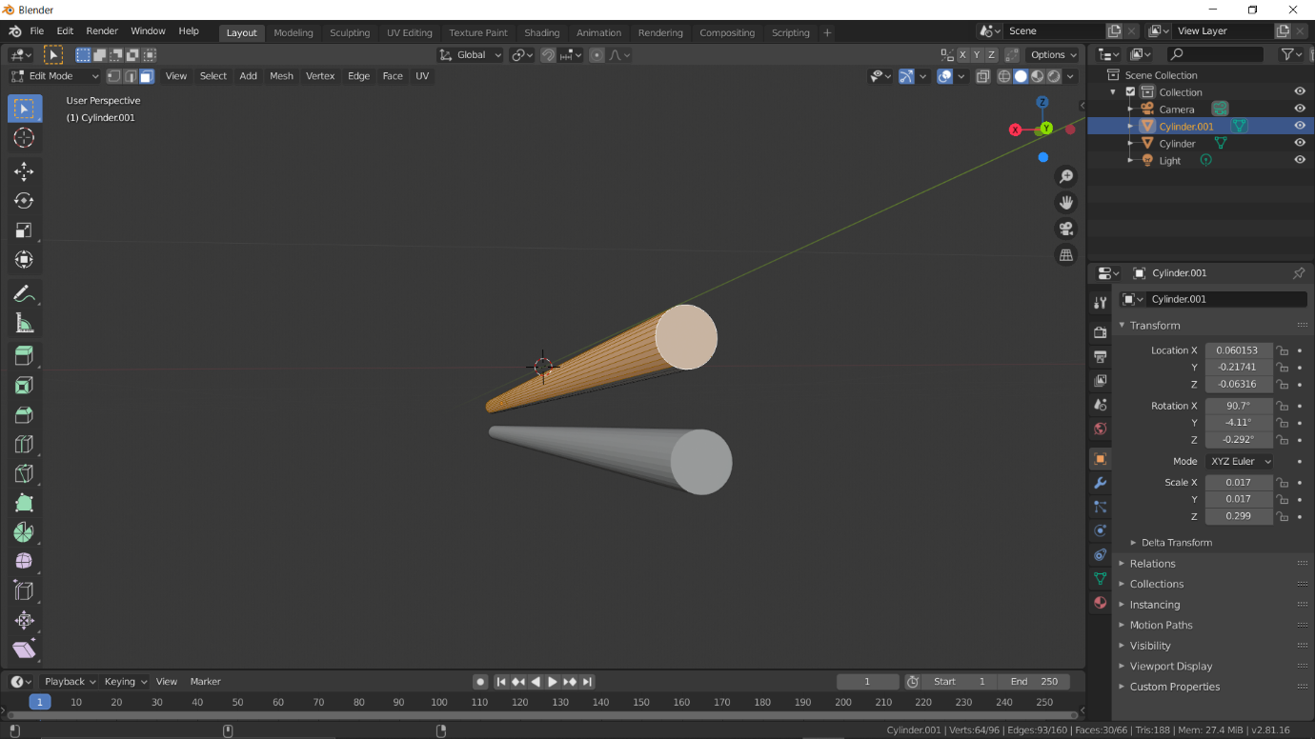

**Step 3**-Now again take the cylinder then remove the curved surface area to get the lens for the scope.

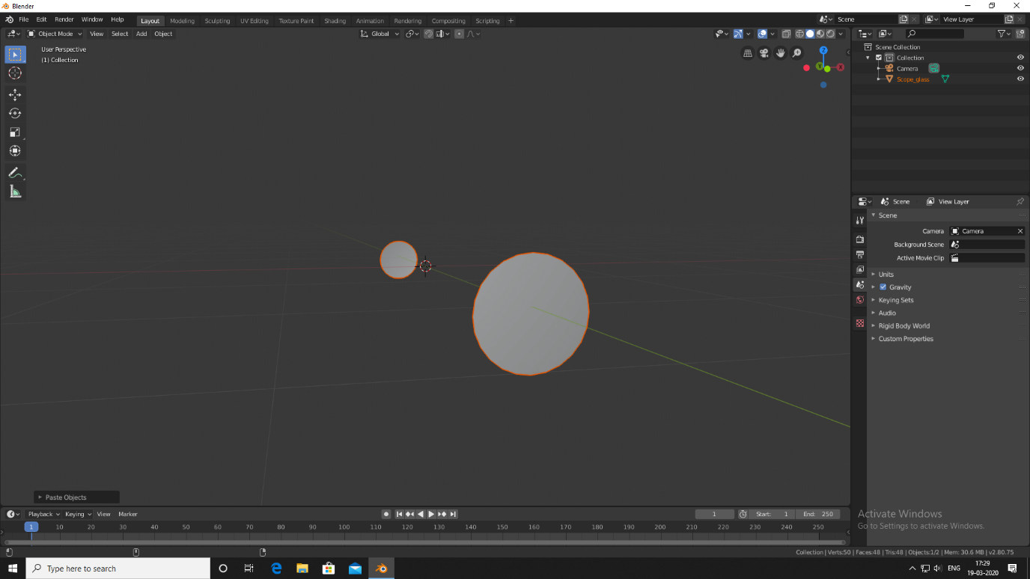

**Step 4**: To make the magazine of the gun , take a cube resize it into Y axis.

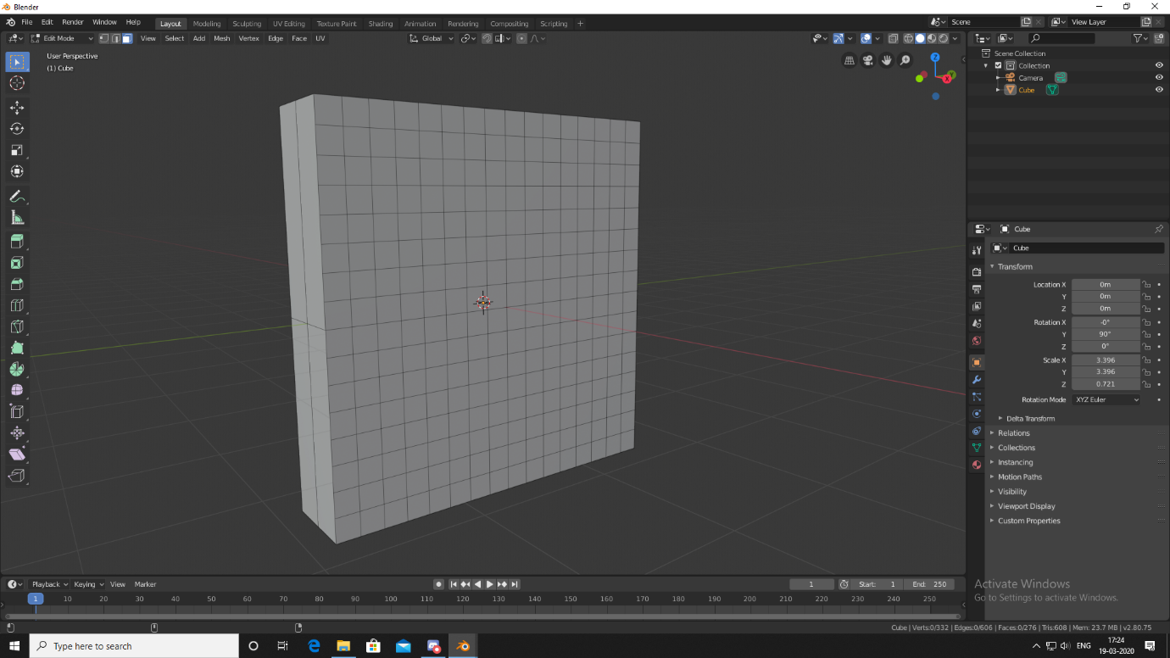

Go in to edit mode and select the faces and use the sub area surface division.

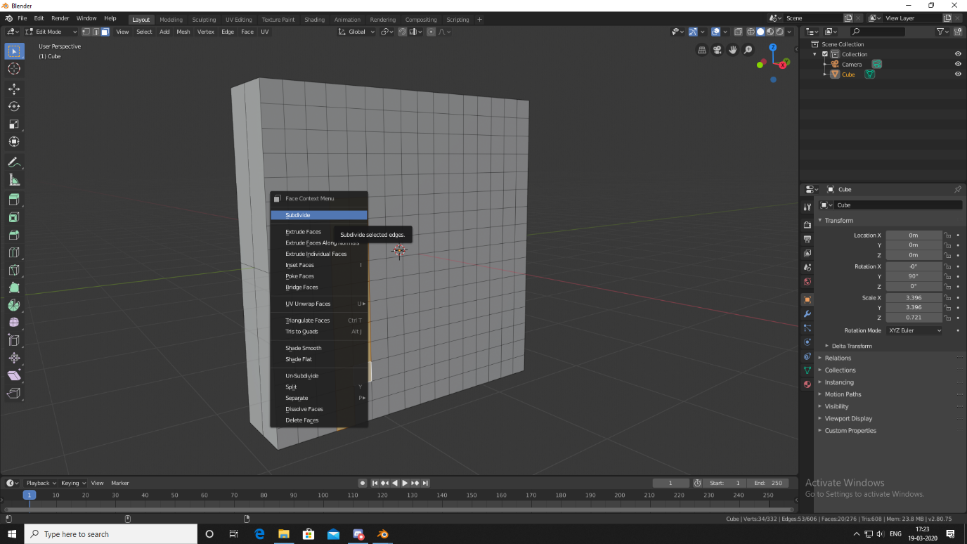

Select these faces and then press E to extrude it and move it a little bit backward .

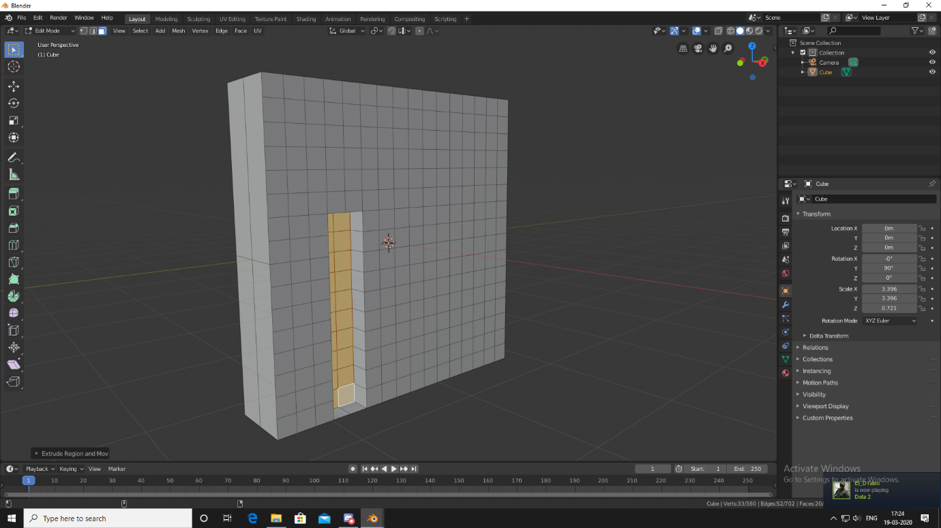

Similarly do the same thing on the other side. Then add the textures and press and hold Z to see the solid and textured mode.

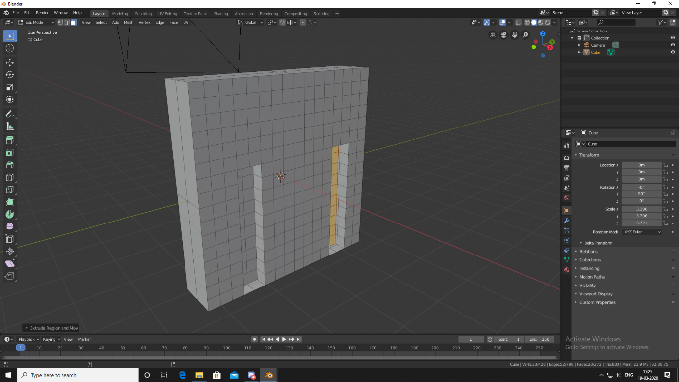

**Step 5**-Now combine all the parts and join them one by one. Press Shift+A and add the camera scene. On the numpad press num 0 to change into camera mode.

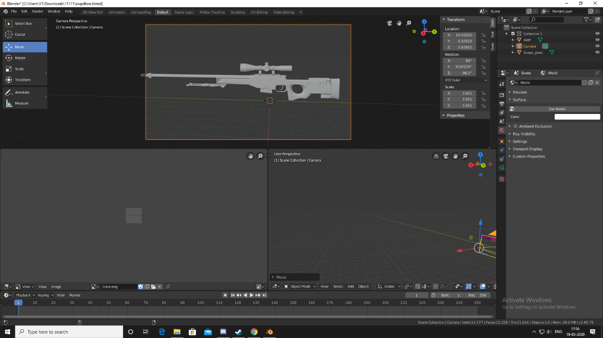

**Step 6**-get the texture file of the AWP and set it onto each part that was made previously.

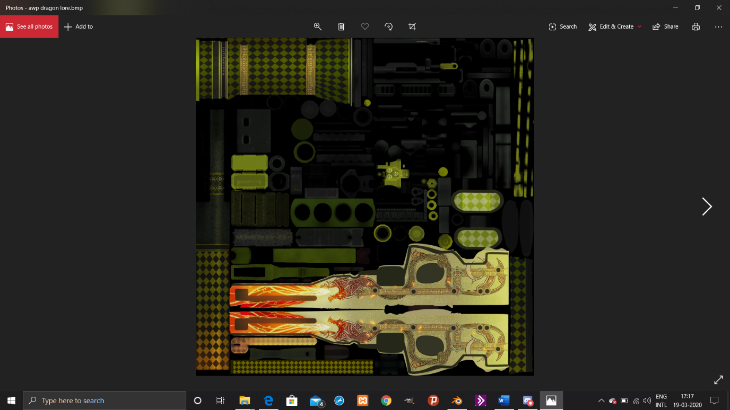

**Step 7**- After adding textures again set the camera and change the output values like save directory, image type, format etc.

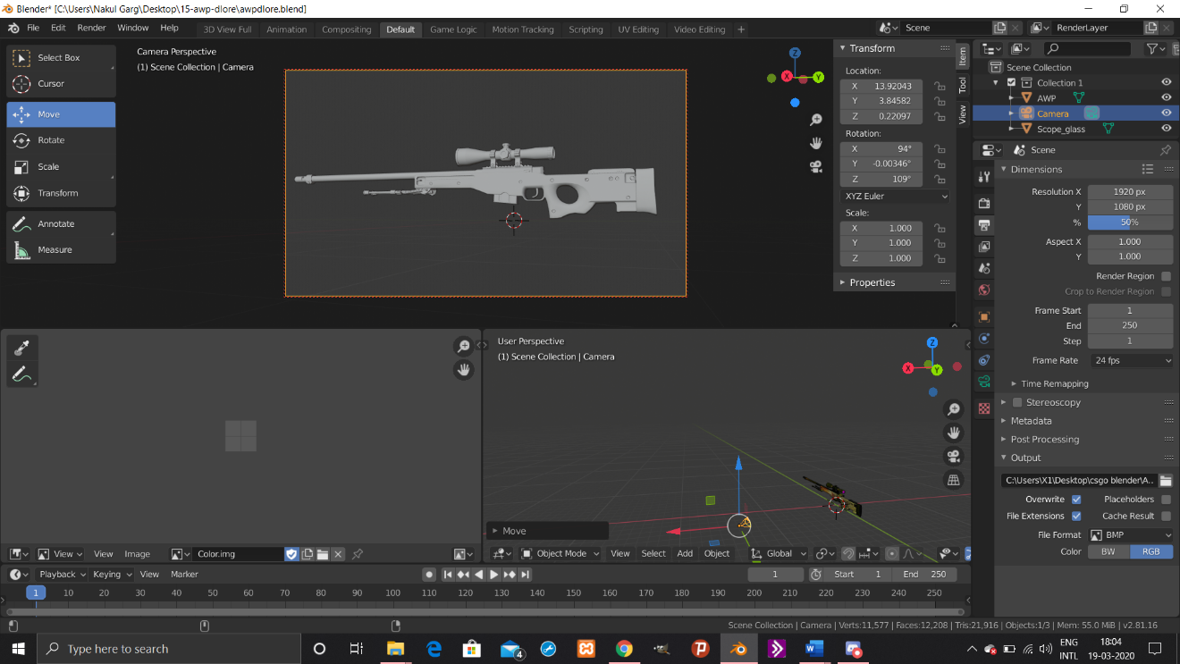

Then click on render and go to the directory that was selected previously, and open the image. We will get our Dragon Lore.

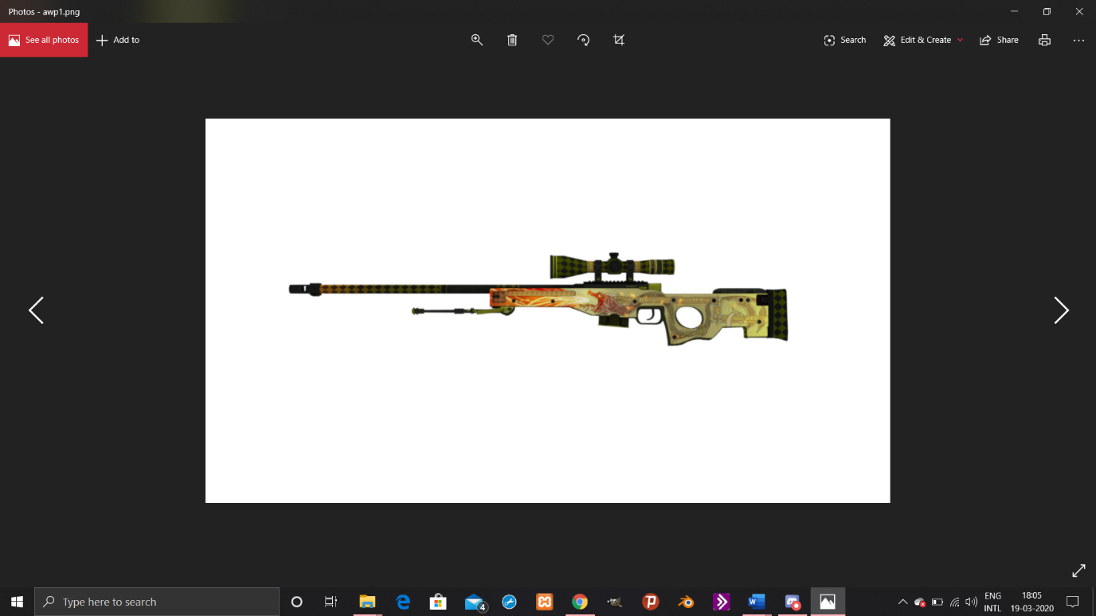

Finally Rendered Image

**Look In Game:-**

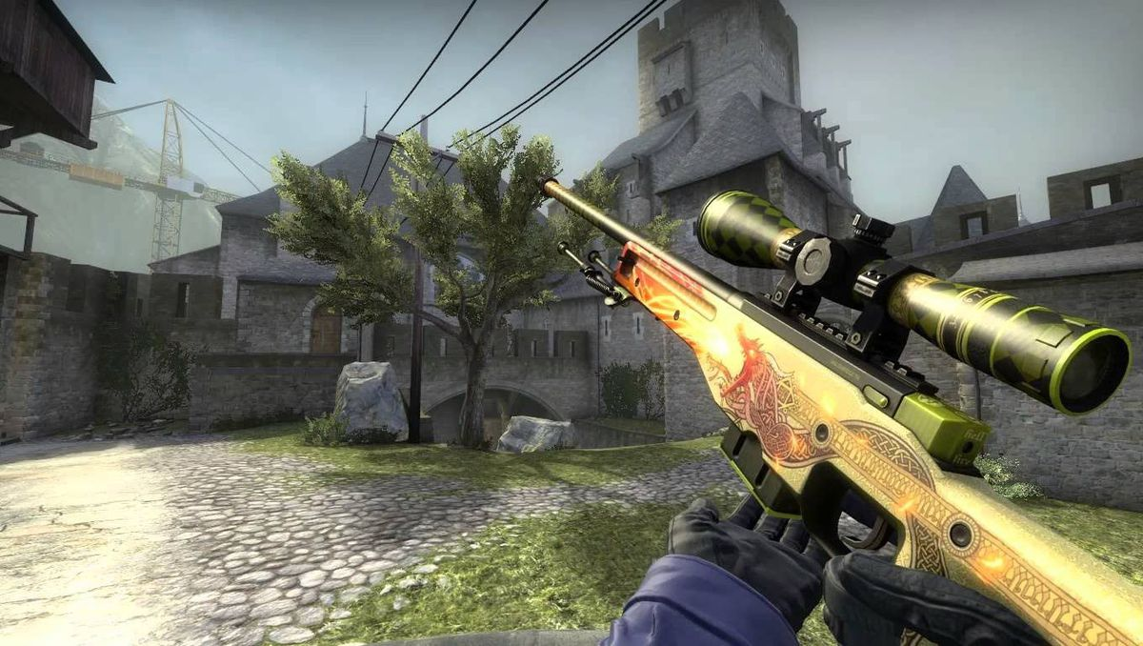

**Measures used in this project**:-

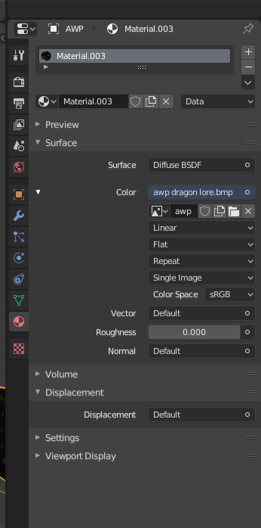

**Drive Link**: https://drive.google.com/drive/folders/1L85IsSNQSySJozFBFY0gN1LjxFjO4Aj0?usp=sharing